Technical Report

Project Exam 2

Priscila Kuhn Derlam

Word count

Summary: **91** | Main text:**1.251**

Table of Contents

1. Summary 3

2. Body 4

2.1. Introduction 4

2.2. Main section of report 4

2.3. Conclusion 4

3. References 5

4. Acknowledgements 6

5. Appendices 7

# 1. Summary

This project exam is about an event decoration website. I was able to work during seven weeks with developing the logo, the style guide, the prototype, and finally the website in ReactJS.

For this website, I used Strapi API, Sass, React Bootstrap, NPM, React Router DOM, React Router Hash Link, YUP, and Axios.

I have submited this website, prototype, and logo to an informal user-testing within my family and friends, so during the process, I made some changes to make this project exam better.

The link to my Project Exam is: <https://projectexam02.netlify.app/>

# 2. Body

## 2.1. Introduction

At a friend’s birthday party, I met Mafalda Holthe, a party decorator. She showed me pictures of several parties which the decoration was handled by her. After that, she asked me if I could help her with building a portfolio, a web page, and a new logo.

She would like to do something simple but fancy. She already had preferences like pastel colors, leaves, and the Jeanne Moderno OT[1] font. Looking to attend to her liking, I designed some logos (Annex 1) and the Style Guide.

Once the design was done, I started coding in React. I used the Strapi[2] API hosted on Heroku[3] as a content manager.

## 2.2. Main section of report

**2.2.1 Design**

To design this webpage and logo I visited many websites[4] within the same theme[5]. In addition, I’ve create a folder in Pinterest to share some ideas with Mafalda[6].

I submitted the logo to the evaluation of four friends who are also into the UX/UI area: Two of them told me, independently, espontaneously that the logo looked like a graveyard headstone. Because of that, I preferred to apply something simpler and more predetermined, which lead me to using Adobe Express[7]. This tool created a new logo, smooth and more contextualized with event decoration (Annex 2).

I finished the logo to started the Style Guide followed by the prototype. In the Style Guide, everything looked elegant and sophisticated, but when I applied it to the prototype, some problems popped up.

I had to check the WCAG properties in Adobe XD[8], and for that I used the Adee Accessibility Tool plugin. I checked all colour contrast with this plugin.

I followed the suggestion by Adobe font to combine the Jeanne Moderno OT[9] font with Minion Pro[10]. However, after showing the original prototype with this font to some friends, I had to change the Jeanne Moderno OT font because it was hard to read (Annex 3).

I adjusted the colours to have a better contrast and followed Adobe Fonts' suggestion to combine the Minion Pro family font with Protipo[11]. The result was delivered to Noroff. (Annex 4)

To create the functional requirements, I followed Terry Reiber tutorial[12].

**2.2.2 Technical**

The API was created and published <https://mafaldaholthe-api.herokuapp.com/>. After this step, I started the code part. For that, I had some examples of hooks, reusable functions, and tutorials to help me developing a React App.

During the code phase, I’ve changed some components, like the radio buttons in the enquiry form. I did it because sometimes the user is inside the birthday page, for instance, but it wishes to contact the business service owner for with regards to a gender revealation or another type event. So to increase the opportunities for the users to contact, radio buttons were removed from the form.

The search bar was not trivial to handle either: I wanted something small that did not attract attention; however, I checked some UI and UX profiles on Instagram[13] and they gave tips about the search bar advising to place an input tag and a button. Because of that, I changed the prototype.

During a question-and-answer session with Professor Martin, he said that the search bar is allowed to return links to services. It was fantastic because now I have this search bar on every page. This makes it easier for both the user and the administrator to verify some service. For this feature I used Kim Chen tutorial[14], just like other tutorials on YouTube[15].

To manage the admin side Professor Abidev helped me in a call. This was essential to reformulate my project exam. At first, he did not understand why I had a "detail contact form" in my project. It was not an enquiry. Then I changed the name of my "detail contact form", but it was not enough, I had to create another “content-typer” with the name enquiry. This was Noroff's requirement for this project exam. Thus, all professors could be able to understand what each form is, and to which features the admin users privileges apply.

That said, the professors helped me to define a new role for my common user in the API, with less privileges than the super admin, to the authenticated user.

To create these forms, I used the Strapi video tutorial about create forms[16].

To add a new service, Professor Jan helped me with an example of code. It was helpful and I could figure out how to post data and images to the API. For this feature I’ve also used an article about this theme[17] and a tutorial on YouTube[18].

In some files, like in "CommonContact.jsx" and "EnquiryContact.jsx", where I get a request for the API, I broke the so called DRY (do not repeat yourself) principle. As repeating should be avoided, for a few days, I tried to create a hook to make this get request using the token. But I found so many errors that it was hard to see any other solution besides leaving it as it is, at least for now.

The project exam was, then, completed, so I sent the URL link to some friends. Their feedback helped me with applying a few more changes: The search bar was placed, originally, nn the navigation bar, but because of its huge width in the mobile version, it seemed to switch places in the welcome section depending on the different screen sizes. That's why I prefered to put it at the top of the page. Probably not the best place yet, but I am still improving this part anyway so I can offer my client the best possible results.

**2.3. Conclusion**

Despite many trials and errors, I learned a lot, I feel more confident in saying, during a job interview, that I know some React JS because of this project: It has provided me with studying more and fostered a problem-fixing behaviour.

The design, right now, is not as identical as I imagined it by the moment I was prototyping in the Adobe XD, but it is still similar.

In conclusion, I am proud to mention that, during this project exam, I made my first contribution to stackoverflow.com in 2 years and 6 months since I have my account.[19]

# 3. References

adobe.com/express (2022). Retrieved August 2022, from: <https://www.adobe.com/br/express/>

adobe.com/products/xd (2022). Retrieved August 2022, from: <https://www.adobe.com/products/xd.html>

canva.com (2022). Retrieved August 2022, from: <https://www.canva.com/pt_pt/>

CKMOBILE. React autocomplete search from API. Retrieved September 2022, from: <https://www.youtube.com/watch?v=Q2aky3eeO40>

COYIER, Chris. A complete guide to Flexbox. Apr 8, 2013 (Aug 30, 2022). Retrieved September 2022, from: <https://css-tricks.com/snippets/css/a-guide-to-flexbox/>

DevDizer. *#8 How to upload files & images via Strapi API*. Retrieved September 2022, from: <https://www.youtube.com/watch?v=2M3pOovhGTk>

dinpynt.no (2022). Retrieved August 2022, from: <https://dinpynt.no/>

favicon.io (2022). Retrieved September 2022, from: <https://favicon.io/favicon-converter/>

festkompaniet.no (2022). Retrieved August 2022, from: <https://www.festkompaniet.no/>

heroku.com (2022). Retrieved August 2022, from: <https://id.heroku.com/login>

icon-sets.iconify.design (2022). Retrieved September 2022, from: [https://icon-sets.iconify.design](https://icon-sets.iconify.design/)

instagram.com (2022). Retrieved September 2022, from: <https://www.instagram.com/>

KANSO, Bassel. *How to upload an image to strapi*. Jul 20, 2021. Retrieved September 2022, from: <https://dev.to/bassel17/how-to-upload-an-image-to-strapi-2hhg>

machadop1407. React-Search-Bar. (repository). Retrieved September 2022, from: <https://github.com/machadop1407/React-Search-Bar/blob/main/search-bar-code/src/Components/SearchBar.js>

MEHALLO, Steve. *Jeanne Moderno OT*. Retrieved August 2022, from: <https://fonts.adobe.com/fonts/jeanne-moderno>

partyking.no (2022). Retrieved August 2022, from: [https://www.partyking.no](https://www.partyking.no/)

pinterest.com (2022). Retrieved August 2022, from: <https://br.pinterest.com/MafaldaHolthe/mafalda-holthe-website/>

PedroTech. *Search Bar in React Tutorial – Cool Search Filter Tutorial*. Retrieved September 2022, from: <https://www.youtube.com/watch?v=x7niho285qs>

pkderlam87. *Answer: Need to set background image from API response in ReactJS.* Sep 7, 2022. Retrieved September, 2022, from: <https://stackoverflow.com/questions/66464128/need-to-set-background-image-from-api-response-in-reactjs/73636826#73636826>

REIBER, Terry. *Documenting Functional Requirements*. Retrieved August 2022, from: <https://www.youtube.com/watch?v=D6R7njeK-qg>

SCAGLIONE, José; BURIAN, Veronika. *Protipo*. Retrieved August 2022, from: <https://fonts.adobe.com/fonts/protipo>

SLIMBACH, Robert. *Minion*. Retrieved August 2022, from: <https://fonts.adobe.com/fonts/minion>

strapi.io (2022). Retrieved August 2022, from: <https://strapi.io/>

STRAPI. Create form. Retrieved September 2022, from: <https://strapi.io/video-library/create-form>

@mifestas_ (2022). Retrieved August 2022, from: <https://www.instagram.com/mifestas_/>

# 

# 4. Acknowledgements

I would like to thank my professors, my friends, my classmates, my client, and my family.

# 5. Appendices

Annex 1

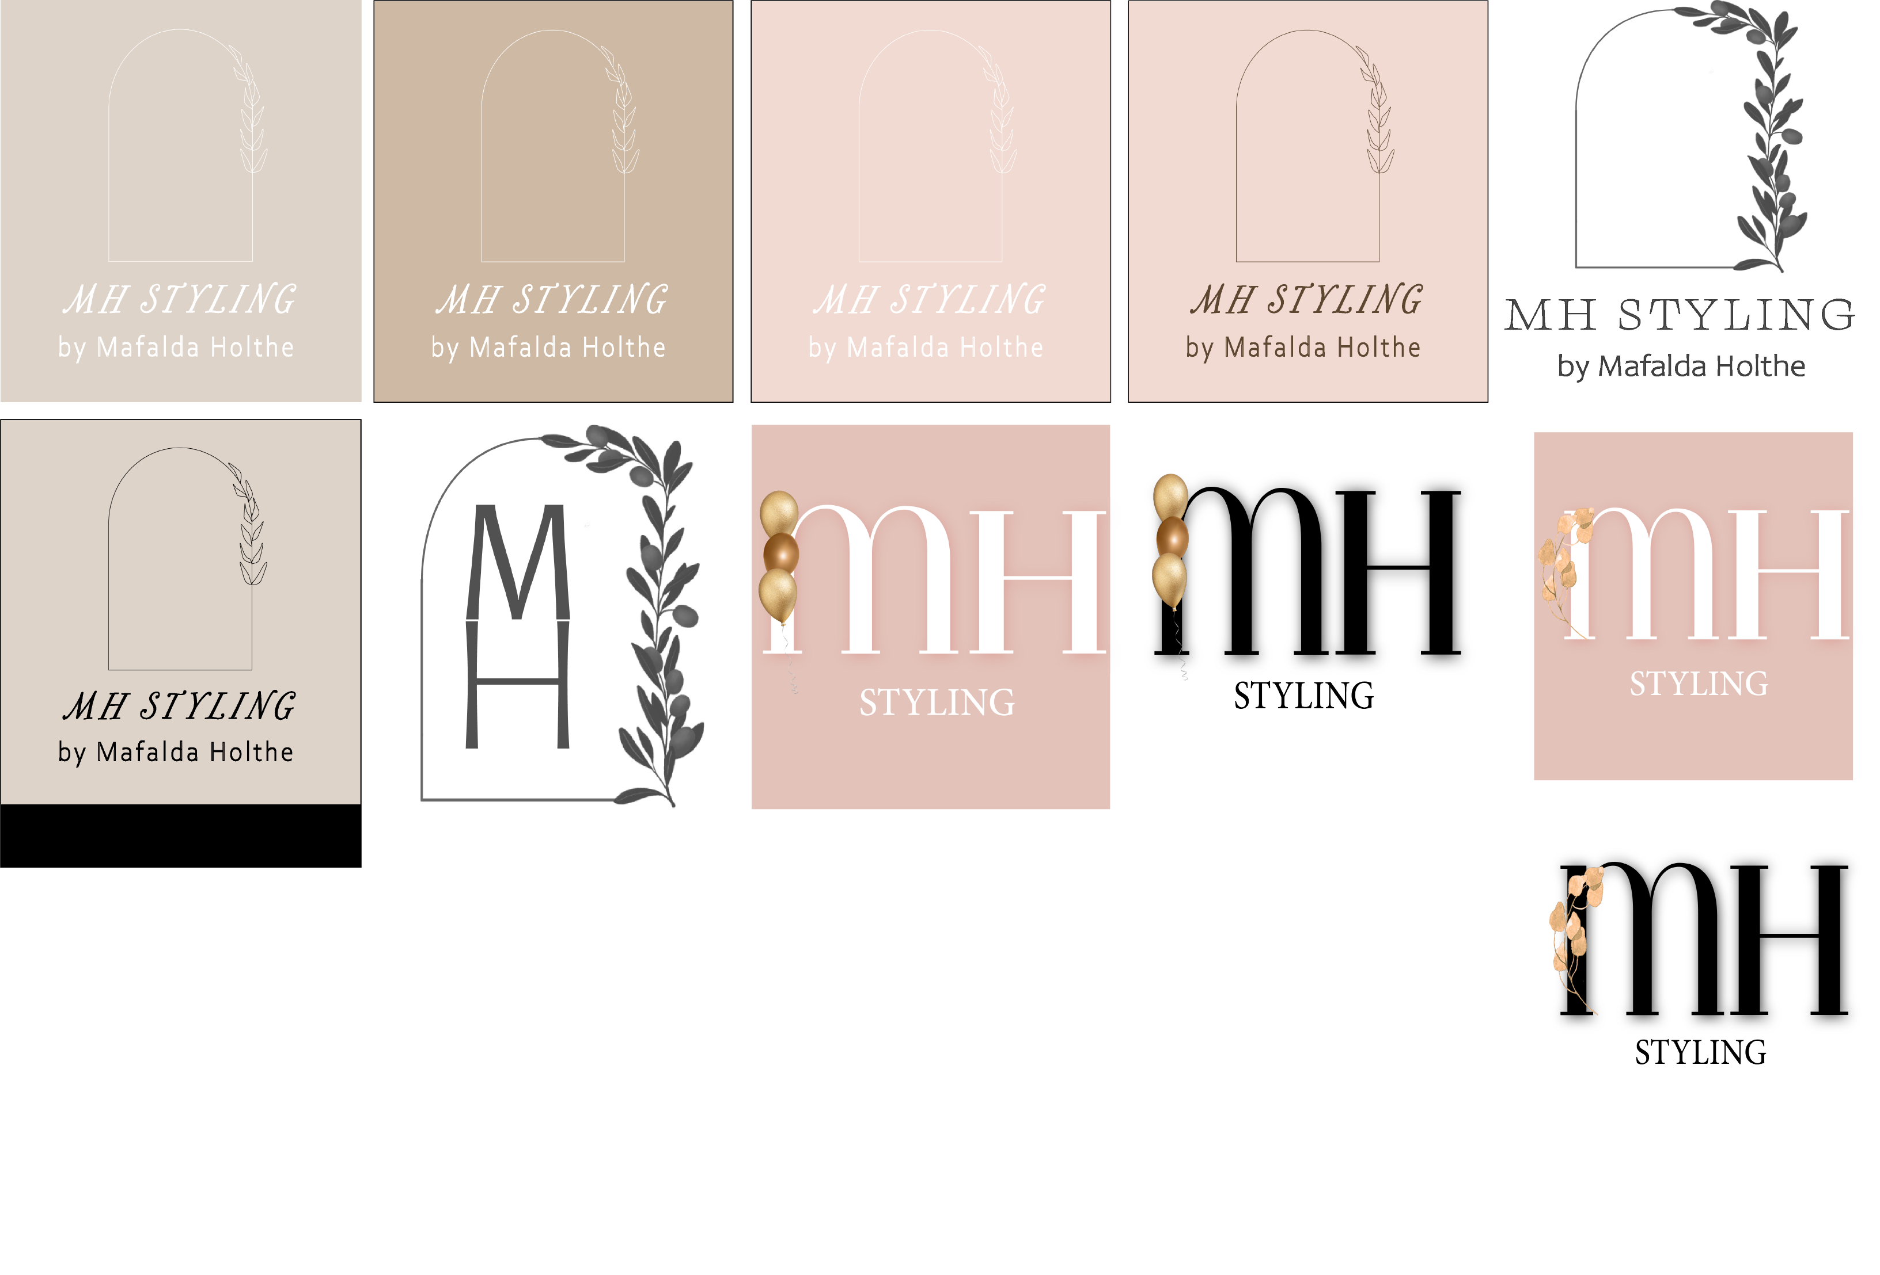

Annex 2

Annex 3

Annex 4

1. MEHALLO, Steve. *Jeanne Moderno OT*. Retrieved August, 2022, from: <https://fonts.adobe.com/fonts/jeanne-moderno>
2. strapi.io (2022). Retrieved August 2022, from: <https://strapi.io/>
3. heroku.com (2022). Retrieved August 2022, from: <https://id.heroku.com/login>
4. canva.com (2022). Retrieved August 2022, from: <https://www.canva.com/pt_pt/>
5. partyking.no (2022). Retrieved August 2022, from: [https://www.partyking.no](https://www.partyking.no/)

   dinpynt.no (2022). Retrieved August 2022, from: <https://dinpynt.no/>

   festkompaniet.no (2022). Retrieved August 2022, from: <https://www.festkompaniet.no/>

   @mifestas_ (2022). Retrieved August 2022, from: <https://www.instagram.com/mifestas_/>
6. pinterest.com (2022). Retrieved August 2022, from: <https://br.pinterest.com/MafaldaHolthe/mafalda-holthe-website/>
7. adobe.com/express (2022). Retrieved August 2022, from: <https://www.adobe.com/br/express/>
8. adobe.com/products/xd (2022). Retrieved August 2022, from: <https://www.adobe.com/products/xd.html>
9. MEHALLO, Steve. *Jeanne Moderno OT*. Retrieved August 2022, from: <https://fonts.adobe.com/fonts/jeanne-moderno>
10. SLIMBACH, Robert. *Minion*. Retrieved August 2022, from: <https://fonts.adobe.com/fonts/minion>
11. SCAGLIONE, José; BURIAN, Veronika. *Protipo*. Retrieved August 2022, from: <https://fonts.adobe.com/fonts/protipo>
12. REIBER, Terry. *Documenting Functional Requirements*. Retrieved August 2022, from: <https://www.youtube.com/watch?v=D6R7njeK-qg>
13. instagram.com (2022). Retrieved September 2022, from: <https://www.instagram.com/>
14. CKMOBILE. React autocomplete search from API. Retrieved September 2022, from: <https://www.youtube.com/watch?v=Q2aky3eeO40>
15. PedroTech. *Search Bar in React Tutorial – Cool Search Filter Tutorial*. Retrieved September 2022, from: <https://www.youtube.com/watch?v=x7niho285qs>

    machadop1407. React-Search-Bar. (repository). Retrieved September 2022, from: <https://github.com/machadop1407/React-Search-Bar/blob/main/search-bar-code/src/Components/SearchBar.js>
16. STRAPI. Create form. Retrieved September 2022, from: <https://strapi.io/video-library/create-form>
17. KANSO, Bassel. *How to upload an image to strapi*. Jul 20, 2021. Retrieved September 2022, from: <https://dev.to/bassel17/how-to-upload-an-image-to-strapi-2hhg>
18. DevDizer. *#8 How to upload files & images via Strapi API*. Retrieved September 2022, from: <https://www.youtube.com/watch?v=2M3pOovhGTk>
19. pkderlam87. *Answer: Need to set background image from API response in ReactJS.* Sep 7, 2022. Retrieved September, 2022, from: <https://stackoverflow.com/questions/66464128/need-to-set-background-image-from-api-response-in-reactjs/73636826#73636826>